Website Design Brief & Sitemap For XXX Solicitors

KEY TABLE
YELLOW: | Anything highlighted in yellow is a comment for you to read and action/delete.

Summary For Your Use
(delete all content on this page below once you have completed it and before you send to the designer. Also delete the logo in the header and the footer – designers will take instruction from you but they won’t like to know the instructions are coming from a third party (trust me on that one)).
This document should be completed and sent to two or three website designers to obtain quotations. The document is sufficiently detailed that you will be able to obtain a fixed price quotation.
Do not worry that you need all of the information instantly available. The process you should follow to ensure maximum efficiency is as follows:
- If you already have a website, KEEP IT LIVE. A bad website is much better than no website at all which I see far too often.
- Complete this website design brief and sitemap (NOT ALL OF THE CONTENT FOR EVERY PAGE – JUST WHICH PAGES YOU WILL NEED IN THE END). If you already have a website, go live with your current content and then update it once the new site is live, otherwise you will delay the project by months.
- Send off the document to three website designers and request your quotations (you can ask me for recommendations but also find a local designer or two – Google “Wordpress Website Designer YOUR TOWN NAME” and look at the websites that they have already produced).
- Now start working on the content whilst waiting for prices to come back and for the design process to begin – briefing a copywriter will help speed along this part of the process.
- Choose your designer and agree your timescale (‘No deadline = total recline’). Do not worry if the designer is not local to you. You can use Zoom to set up meetings and share screens to talk through designs. Your web designer will start working on draft designs.
- Brief your copywriter for any new pages required or to beef up old ones which are a bit light on copy (i.e. well under 400 words). Use the copywriting precedent I provide inside Marketing4Solicitors.
- Agree the website design (check it against your brief as THEY WILL miss parts or ignore them if they do not want to put them in).
- Sign off the agreed visuals.
- Finish the content (copywriting, staff photos for about us page etc) and send it off to the designer to complete the website.
- Before you sign off the website, check it carefully against the website design brief, prepare a snagging list then ensure this is completed before you sign off/make final payment. NB Once your website is live your website designer will not be so interested in your welfare, so it is vital that you ensure the website is complete before you allow it to ‘go live’. If you have mentoring included, ask me to review the site BEFORE you sign off the completed website.
Website URL: www.
Overview: The brief is to design a lead generation website for NAME OF PRACTICE who details of service – specialist or general.
Design: The design should use the colour scheme from the current website and logo, although if other colours are needed to improve the visual effect of the website and to assist with usability and lead generation this will be acceptable.

Layout: The website should follow this overall wireframe website layout for the desktop version:
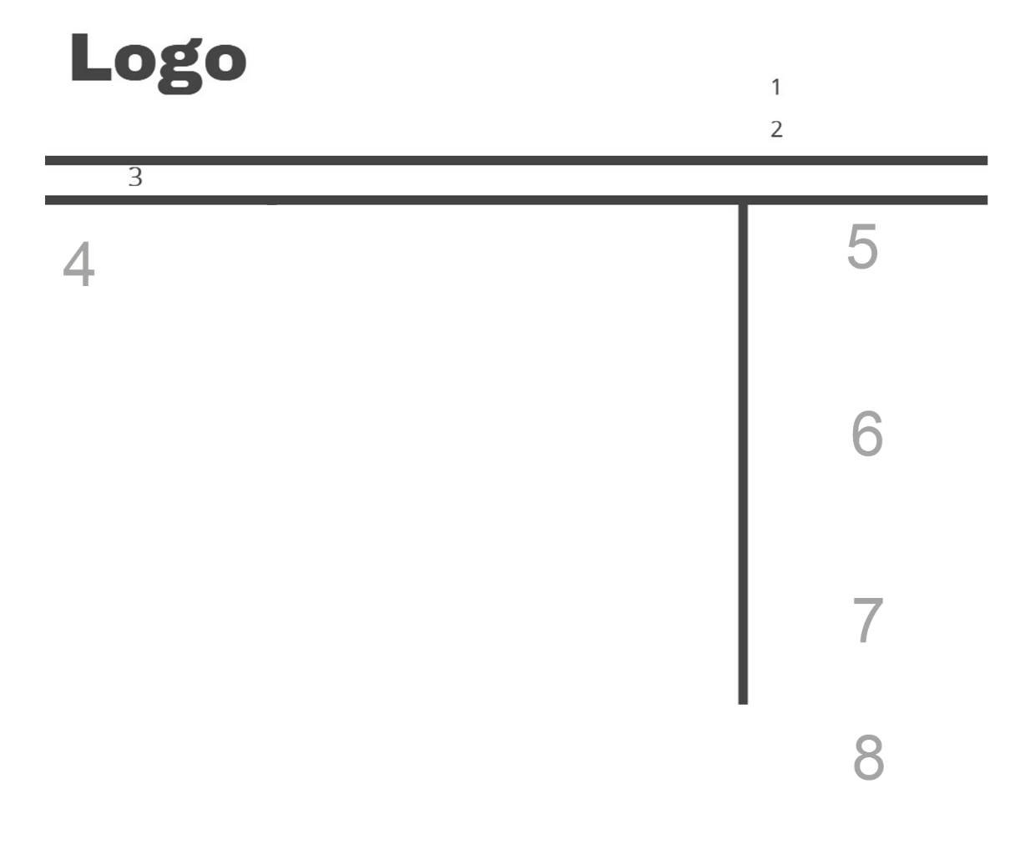
- Logo: Plus word “Solicitor” below or if a consultant your consultancy firm name. Eg John Smith Solicitor, part of Consultancy Solicitors Name.
- 1: Telephone number
- 2: Email address
- 3: Top navigation – eg Home, Services, About Us, Free Enquiry, Contact
- 4: Central Content
- 5: Optional sub navigation (eg list the pages in this section of the site – so all pages in Family section if in family, all Conveyancing if in conveyancing etc)
- 6: Free enquiry form or link to free enquiry form (or if B2B – Marketing DNA Nurture – your ‘item of value’ download (see Blueprint 4)).
- 7: Reviews (testimonials).
- 8: Why choose box

Layout: The website should follow this overall wireframe website layout for the mobile version of the website, with the overall size shrinking to fit a mobile device, the navigation going beneath a drop down mobile menu and the right column (5-7) moving below the copy column (4):

More Detail On Layout/Design
Home Page Design (different from internal pages)
- Reasonably thin header
- Attractive home page visual – images to link to 3 main service areas. Right column not essential.
- Easy access to contact page.

Internal Service Pages
- Reasonably thin header
- Left side content accounting for 2/3rds of the width;
- Right hand ‘call to action column’ (see wireframe above).
- On a mobile view this right hand column will move to the bottom of the content;
Right Side:
Free Enquiry Form: (Marketing DNA Now services – see Blueprint 4).
Title: Make A Free Enquiry
“Call Free On 0800 7076004 or complete this short enquiry (no cost or obligation)
Fields
- First Name
- Surname
- Email
- Telephone Number
- Brief details
- Send Free Enquiry (button).
If DNA Marketing Nature Service also include a download for your item of value (brochure/guide):

Reviews: Headline “What Clients Say”
Reviews in quotes pulled back from a database and changed by clicking left/right arrow
“Click to read more >>” redirects to reviews page.
Why Choose Us/Me Box.
Box featuring [your chosen trust methods such as media coverage logos, external endorsements or specialist qualifications, how many clients out of 5/10 would use your services again - linking to a separate page detailing this coverage/qualifications in more detail]. Link to a page explaining why this makes you the best solicitor for their needs.

Website Development Elements
Cookies: Include Cookie acceptance terms to appear at the foot of the page (not the top)
Content
Management: Please use Wordpress for content management, ensuring that all of the website, including navigation, can be amended from within the Wordpress login. I wish to be able to edit the site using The Wordpress Classic editor, and would like the design elements of the site to be built into the template, not by using Divi Builder, Elementor or other page builders.

Menu: The menu should be fully accessible to me so that I can easily add new pages to the menu as I create them.

Blog: Please include a blog on the website with a SEO friendly URL, for example www.websiteurl.co.uk/reading-solicitors-advice/. The design of the blog should mirror the wireframe above. The home page of the blog should include the headline and first paragraph from the latest blog, then beneath that a list of ALL previous blogs. The date field should be removed from the blog landing page and each of the blogs so as to avoid dating the content.
Google
Analytics: Google Analytics should be added to every page of the website (preferably in a separate header/footer folder so easy to update/change)

Address: The practice address should feature on the left hand side under the navigation or at the bottom of every page of the website (Delete if not targeting local clients)

301 Redirects: 301 redirects must be used to redirect to the equivalent new page on the new website (delete if brand new website – leave in if not. This ensures that any traffic which is already going to your old website will be redirected to the relevant page on your new website – you can see Google’s explanation here: http://support.google.com/webmasters/bin/answer.py?hl=en&answer=93633)

404 Page: The 404 Page Not Found should have a headline of “Sorry, the page you are looking for cannot be found.” followed by a paragraph “Please use the navigation on the left or the links below to find what you are looking for, thank you.” The Home page links should then appear below in the body copy of the page without the introductory home page paragraph.

Page Speed: The mobile and desktop versions of the website should load at higher than 80/100 score on the Google Page Speed Insights test: https://developers.google.com/speed/pagespeed/insights/

Enquiry
Form: 2 forms (identical fields). Website enquiry form on /online-enquiry redirecting to /online-enquiry-thank-you upon completion so that you can track goals in Analytics and Google Ads. This should be in addition to the contact form on the contact page.

Plugins: Include Yoast or Rank Math SEO plugin for the blog and pages
XML Sitemap generator

Sitemap
This is where you list all of the pages that you will need. If this is a new website, start small and then, so long as the website is designed following the guidance above, it should be easy for you to add new pages as you grow.

Top Navigation Items
(no expanding navigation – linking to one page only):

- Home
- Business Services
  - Service 1 eg Employment law
    - Sub service page 1 - eg unfair dismissal
  - Service 2 eg Commercial Law
    - Sub service page
- Individual Services
  - Service 1 eg Conveyancing
    - Sub service page 1 - eg Remortgage
  - Service 2 eg Personal Injury
    - Sub service page 1
    - Sub service page 2
- About Us
- Contact Us
- Free Enquiry
- If you are using a call centre, add this paragraph: [Please also create a separate enquiry form page with exactly the same fields as the main enquiry for our call centre to use. The URL should be “/cc-free-enquiry” leading to a new confirmation page of “cc-enquiry-confirmation” to enable us to track leads completed by the call centre separately.]

